# Database vs Data Warehouse vs Data Lake vs Delta Lake

**Introduction**In today’s data-driven world, organizations rely on efficient data management systems to store, process, and analyze massive amounts of information. Understanding the differences between a Database, Data Warehouse, Data Lake, and Delta Lake is crucial for building scalable, efficient, and modern data architectures. This document provides a clear comparison, highlighting their features, use cases, and advantages.

## 1. Database



A Database is a structured collection of data organized for quick access, management, and updating. It is optimized for transactional processing (OLTP — Online Transaction Processing).

Common Database Types: Relational (SQL), Non-relational (NoSQL).

Examples: MySQL, PostgreSQL, MongoDB, Microsoft SQL Server.

* Key Features:
* • Stores structured data in tables.
* • Ideal for day-to-day business operations.
* • Supports CRUD operations — Create, Read, Update, Delete.
* • Ensures data integrity through ACID properties.

## 2. Data Warehouse

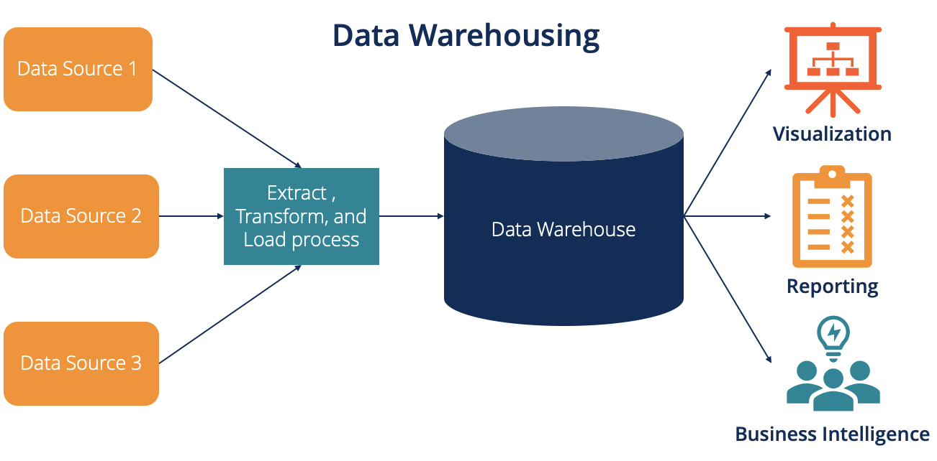

A Data Warehouse is designed for analytical processing (OLAP — Online Analytical Processing). It consolidates data from multiple sources for reporting and business intelligence.

Examples: Amazon Redshift, Snowflake, Google BigQuery, Azure Synapse Analytics.

* Key Features:
* • Stores structured and historical data.
* • Optimized for complex queries and analysis.
* • Uses ETL (Extract, Transform, Load) processes.
* • Enables trend analysis and decision support.

## 3. Data Lake

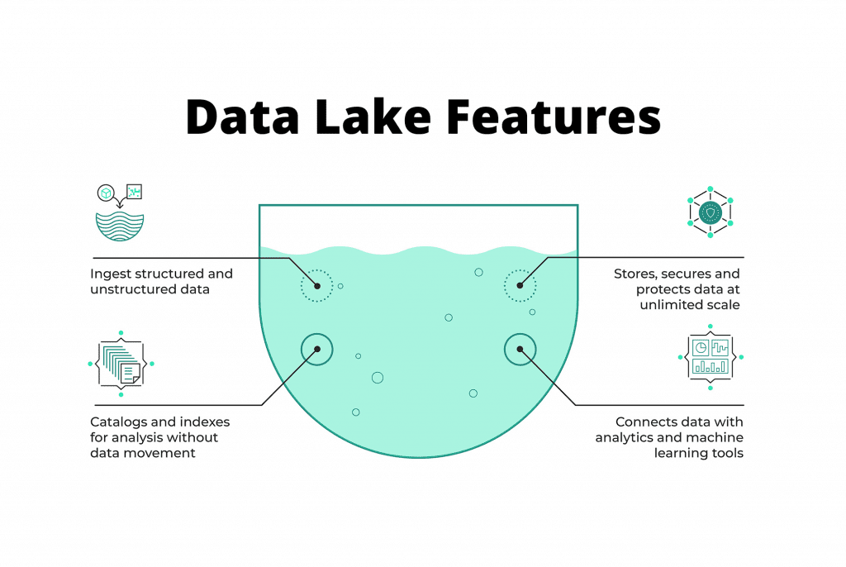

A Data Lake is a centralized repository that allows storage of raw data in its native format — structured, semi-structured, or unstructured. It is often used for big data analytics and machine learning applications.

Examples: Azure Data Lake, Amazon S3, Hadoop HDFS.

* Key Features:
* • Stores all types of data without schema-on-write.
* • Highly scalable and cost-efficient.
* • Used by data scientists for AI/ML workloads.
* • Requires schema-on-read when querying data.

## 4. Delta Lake

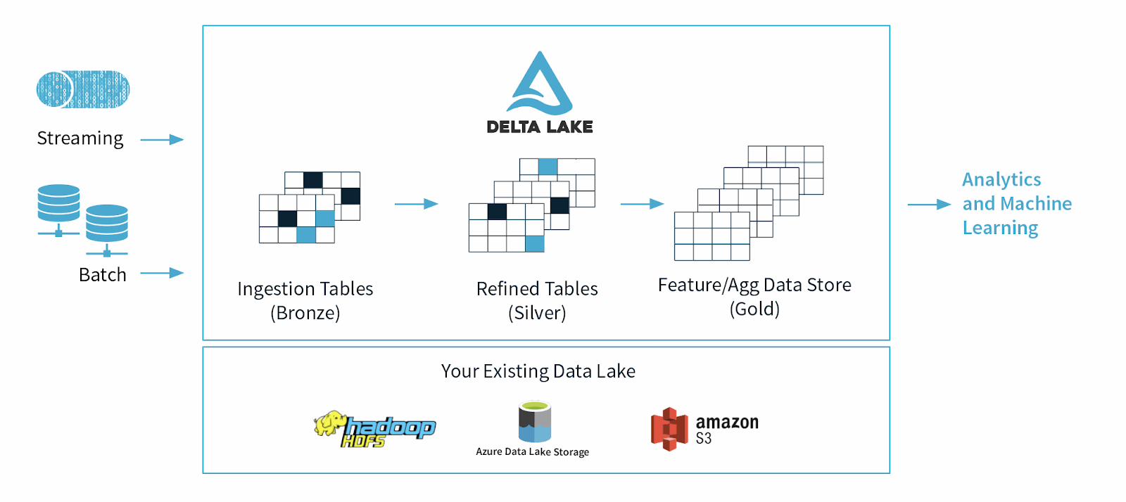

Delta Lake is an open-source storage layer that brings reliability and performance to data lakes. It adds ACID transactions, scalable metadata handling, and unified batch/streaming data processing capabilities.

Examples: Databricks Delta Lake, Apache Spark Delta Lake.

* Key Features:
* • Ensures ACID transactions on big data.
* • Supports time travel and data versioning.
* • Unifies streaming and batch data processing.
* • Built on top of open-source Parquet format.

## 5. Comparison Summary

The following table summarizes the key differences among the four data storage technologies:

|  |  |  |  |  |
| --- | --- | --- | --- | --- |
| Aspect | Database | Data Warehouse | Data Lake | Delta Lake |
| Data Type | Structured | Structured | All types | All types with ACID |
| Purpose | Transactions (OLTP) | Analytics (OLAP) | Storage for raw data | Reliable data lake |
| Storage | Tables | Tables (Star Schema) | Files (Object storage) | Enhanced Parquet files |
| Scalability | Moderate | High | Very High | Very High |
| Use Case | App data | BI and reports | AI/ML and big data | Unified analytics |

## 6. Conclusion

Each data storage technology serves a unique purpose within the modern data ecosystem. Databases handle real-time operations, Data Warehouses support business intelligence, Data Lakes store diverse raw data, and Delta Lakes enhance reliability and performance on top of Data Lakes. Organizations often combine these systems to build a comprehensive, end-to-end data architecture.